
Holy Cross College

Semester 1 Examination 2015

Question/Answer Booklet

Year 10 Science
Please place your student identification label in this box
(Adjusted)

Student Name
Student’s Teacher

Time allowed for this paper

Reading time before commencing work: 5 minutes
Working time for paper: 50 minutes

Materials required/recommended for this paper

To be provided by the supervisor

This Question/Answer Booklet
Data Sheet

To be provided by the candidate

Standard items: pens, pencils, eraser, correction fluid, ruler, highlighters.
Special items: non-programmable calculators satisfying the conditions set by the School Curriculum and Standards Authority for this course.

Important note to candidates

No other items may be taken into the examination room. It is your responsibility to ensure that you do not have any unauthorised notes or other items of a non-personal nature in the examination room. If you have any unauthorised material with you, hand it to the supervisor before reading any further.

Structure of this paper

Section | Number of questions available | Number of questions to be answered | Suggested working time  (minutes) | Marks available | Percentage of exam
Section One:  Multiple Choice | 26 | 26 | 20 | 26 | 41
Section Two:  Short Answer | 6 | 6 | 30 | 38 | 59
 |  |  |  | 64 | 100

Instructions to candidates

1. The rules for the conduct of examinations at Holy Cross College are detailed in the College Examination Policy. Sitting this examination implies that you agree to abide by these rules.

2. Write your answers in this Question/Answer Booklet.

3. Working or reasoning should be clearly shown when calculating or estimating answers.

4. You must be careful to confine your responses to the specific questions asked and to follow any instructions that are specific to a particular question.

5. Spare pages are included at the end of this booklet. They can be used for planning your responses and/or as additional space if required to continue an answer.

• Planning: If you use the spare pages for planning, indicate this clearly at the top of the page.
• Continuing an answer: If you need to use the space to continue an answer, indicate in the original answer space where the answer is continued, i.e. give the page number.
• Fill in the number of the question(s) that you are continuing to answer at the top of the page.

SECTION 1 MULTIPLE CHOICE (26 marks)

Choose the best answer for each question in the Multiple Choice Question booklet.

Mark your selection with a cross.

1 | (a) | (b) | (c) | (d)
2 | (a) | (b) | (c) | (d)
3 | (a) | (b) | (c) | (d)
4 | (a) | (b) | (c) | (d)
5 | (a) | (b) | (c) | (d)
6 | (a) | (b) | (c) | (d)
7 | (a) | (b) | (c) | (d)
8 | (a) | (b) | (c) | (d)
9 | (a) | (b) | (c) | (d)
10 | (a) | (b) | (c) | (d)
11 | (a) | (b) | (c) | (d)
12 | (a) | (b) | (c) | (d)
13 | (a) | (b) | (c) | (d)
14 | (a) | (b) | (c) | (d)
15 | (a) | (b) | (c) | (d)
16 | (a) | (b) | (c) | (d)
17 | (a) | (b) | (c) | (d)
18 | (a) | (b) | (c) | (d)
19 | (a) | (b) | (c) | (d)
20 | (a) | (b) | (c) | (d)
21 | (a) | (b) | (c) | (d)
22 | (a) | (b) | (c) | (d)
23 | (a) | (b) | (c) | (d)
24 | (a) | (b) | (c) | (d)
25 | (a) | (b) | (c) | (d)
26 | (a) | (b) | (c) | (d)

SECTION 2 SHORT ANSWER (38 marks)

Attempt all questions. Write your answers in the spaces provided.

1. In the table below, choose the correct statement for each word given. Write the letter of the correct statement next to the word.

WORD | CORRECT  LETTER | STATEMENT
dominant |  | A - how an organism looks due to its genes.
genotype |  | B - hides the other gene in a pair (e.g. T).
gamete |  | C - see a new characteristic in an organism.
phenotype |  | D - same genes in a pair (e.g. TT, tt).
pure-bred |  | E - gene that is hidden by another gene (e.g. t).
incomplete dominance |  | F - the genes for a particular characteristic.
hybrid |  | G - sex cell of an organism.
recessive |  | H - different genes in a pair (e.g. Tt)

(8 marks)

2. Tommy is heterozygous for brown eyes while Susie is homozygous for blue eyes. Complete the Punnett square below to show the possibilities that would result if Tommy and Susie had children.
 |  | Tommy
 |  | B | b
Susie | b
Susie | b
(4 marks)

3. The chart below shows the inheritance of a rare (but not serious) blood disorder through four generations of a family. Individuals with the condition are represented by the shapes that have been shaded in.

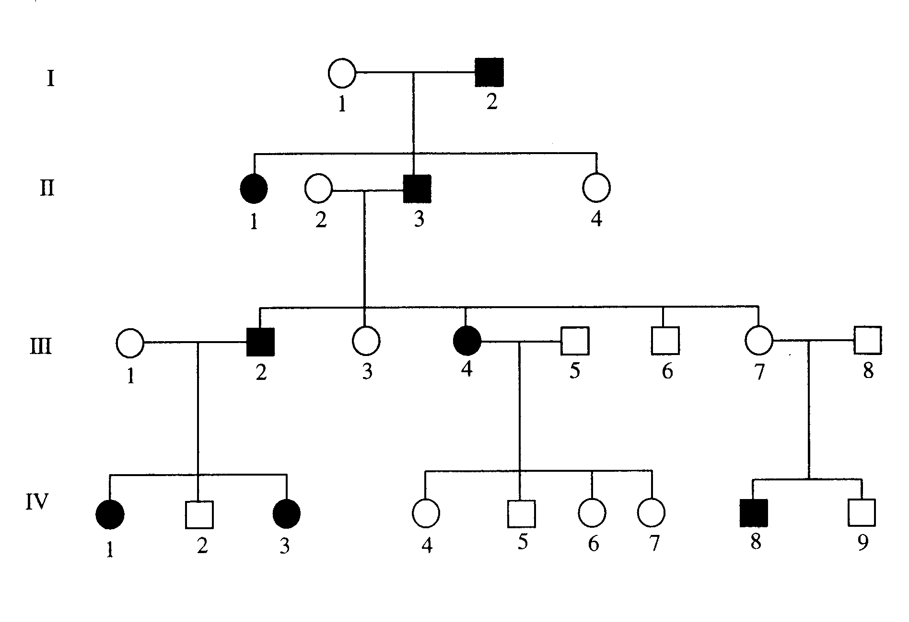

(a) How many people in total show the disorder in this family? (1 mark)

(b) How many of the people with the disorder are female?
(1 mark)

(c) How many children did person II 2 and II 3 have in total?
(1 mark)

4. Use the listed words to complete the sentences below.

two | chromosomes | diploid | dominant
physical | generation | meiosis | genotypes

The of cells contains genes made of DNA.

Genes determine many characteristics (e.g. eye colour).

Gametes are formed by a type of cell division called .

The fertilised egg has a number of chromosomes.

X and Y are the sex chromosomes. Females have X chromosomes and males have an X and a Y chromosome.

Different forms of a gene are called alleles. Alleles can be or recessive. Two copies of a recessive gene are required for the characteristic to be expressed.

Punnett squares are useful tools to predict the proportion of and phenotypes in the offspring.

Pedigree diagrams are useful in showing how various genes are transferred from one

to another.
(8 marks)

5. Use the words listed below to complete the following sentences.

protostar | billion | Milky Way | giants | fusion
constellations | space | nebulae | expansion

Groups of stars form patterns that are called .

Our solar system is part of a large galaxy called the .

Clouds of dust and gas in interstellar space are called .

According to the Big Bang Theory, the universe is about 13.7 years old.

The first stage of the Big Bang involved the formation of time and .

Space then underwent rapid .

Stars are formed when gravity causes gas and dust to come together and heat up.

Eventually a is formed and then finally a star.

Stars like our sun evolve into red before they explode.

Stars generate their energy by nuclear in which hydrogen changes to helium.
(9 marks)

6. Choose the correct definition for the term in the first column of the table below. Write the correct letter in the second column.

TERM | CORRECT LETTER | DEFINITION
Black dwarf |  | A: Pattern formed by a group of stars.
Nova |  | B: Formed by the expansion of a star about  the size of our Sun.
Red giant |  | C: Remains of the death of a massive star.
Black hole |  | D: Small, dead star that emits no light.
Constellation |  | E: Final stage in the development of a star.
Protostar |  | F: Explosion of the outer layers of an average-  size star.

(6 marks)

END OF EXAMINATION

